Exp:1A
Helloworld.java

import java.applet.*;
import java.awt.*;

public class HelloApplet extends Applet {
public void paint(Graphics g) {
g.drawString("Hello World", 50, 50);
}
}

Helloworld.html
<html>
<body>
<applet code="HelloApplet.class" width="300" height="200">
</applet>
</body>
</html>

Output
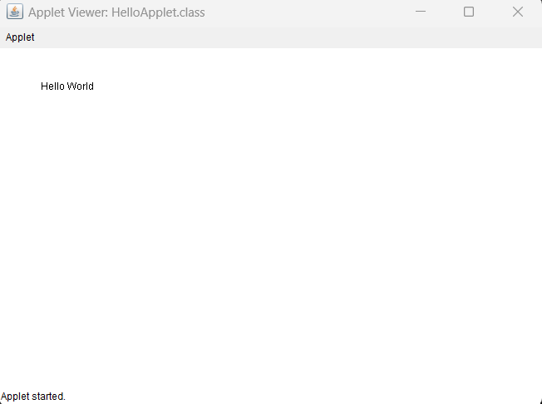

Exp:1B
import javax.swing.*;
import java.awt.*;
import java.awt.event.*;

public class KeyEventDemo extends JFrame implements KeyListener {

String msg = "Assign1: A JAVA program to demo status of key";

public KeyEventDemo() {
setTitle("Key Event Demo");
setSize(400, 200);
setDefaultCloseOperation(JFrame.EXIT_ON_CLOSE);
addKeyListener(this);
setVisible(true);
}

public void keyReleased(KeyEvent k) {
msg = "Key Released";
repaint();
}

public void keyTyped(KeyEvent k) {
msg = "Key Typed";
repaint();
}

public void keyPressed(KeyEvent k) {
msg = "Key Pressed";
repaint();
}

public void paint(Graphics g) {
super.paint(g);
g.drawString(msg, 50, 100);
}

public static void main(String[] args) {
new KeyEventDemo();
}
}

Output
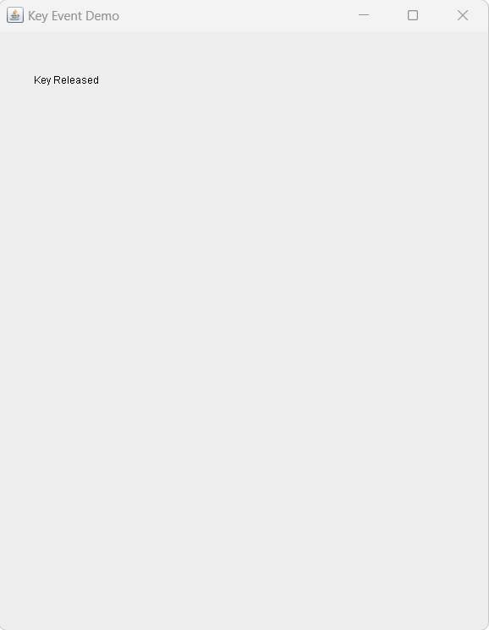

Exp2

import java.awt.*;
import java.awt.event.*;

public class MouseFrameDemo extends Frame implements MouseListener {

String msg = "Move mouse into the frame";

public MouseFrameDemo() {
setTitle("Mouse Event Demo");
setSize(400, 300);
addMouseListener(this);
setVisible(true);
addWindowListener(new WindowAdapter() {
public void windowClosing(WindowEvent we) {
System.exit(0);
}
});
}
public void mouseClicked(MouseEvent e) {
msg = "Mouse Clicked";
repaint();
}
public void mouseEntered(MouseEvent e) {
msg = "Mouse Entered";
repaint();
}
public void mouseExited(MouseEvent e) {
msg = "Mouse Exited";
repaint();
}
public void mousePressed(MouseEvent e) {}
public void mouseReleased(MouseEvent e) {}
public void paint(Graphics g) {
g.drawString(msg, 100, 150);
}
public static void main(String[] args) {
new MouseFrameDemo();
}
}

Output

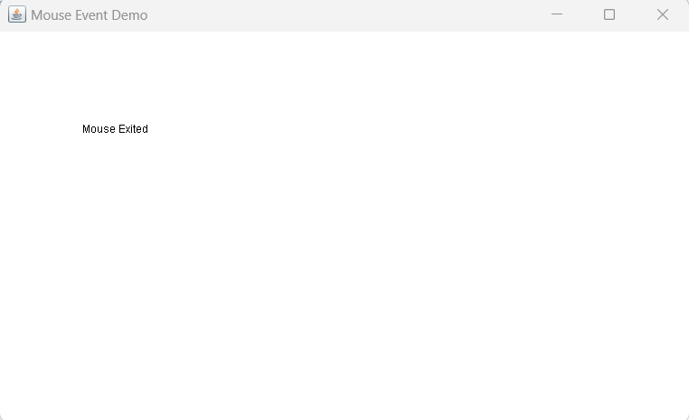

Exp 3
import java.awt.*;
import java.awt.event.*;

public class StudentResultGUI extends Frame implements ActionListener {

Label l1, l2, l3, l4, l5;
TextField t1, t2, t3, t4, t5;
Button btn;
public StudentResultGUI() {
setTitle("Enter Your Marks Out of 100");
setSize(400, 300);
setLayout(new GridLayout(6, 2));
l1 = new Label("MIC:");
l2 = new Label("DBMS:");
l3 = new Label("FJP:");
l4 = new Label("DC:");
l5 = new Label("EFT");
t1 = new TextField();
t2 = new TextField();
t3 = new TextField();
t4 = new TextField();
t5 = new TextField();
btn = new Button("Show Result");
btn.addActionListener(this);

add(l1); add(t1);
add(l2); add(t2);
add(l3); add(t3);
add(l4); add(t4);
add(l5); add(t5);
add(btn);

addWindowListener(new WindowAdapter() {
public void windowClosing(WindowEvent we) {
System.exit(0);
}
});

setVisible(true);
}

public void actionPerformed(ActionEvent e) {
int m1 = Integer.parseInt(t1.getText());
int m2 = Integer.parseInt(t2.getText());
int m3 = Integer.parseInt(t3.getText());
int m4 = Integer.parseInt(t4.getText());
int m5 = Integer.parseInt(t5.getText());

int total = m1 + m2 + m3 + m4 + m5;
double percentage = total / 5.0;

String result;
if (percentage >= 40)
result = "PASS";
else
result = "FAIL";

new ResultFrame(total, percentage, result);
}

public static void main(String[] args) {
new StudentResultGUI();
}
}
class ResultFrame extends Frame {

public ResultFrame(int total, double percentage, String result) {
setTitle("Result");
setSize(300, 200);
setLayout(new GridLayout(3, 1));

add(new Label("Total Marks: " + total));
add(new Label("Percentage: " + percentage));
add(new Label("Result: " + result));

setVisible(true);

addWindowListener(new WindowAdapter() {
public void windowClosing(WindowEvent we) {
dispose();
}
});
}
}

Output
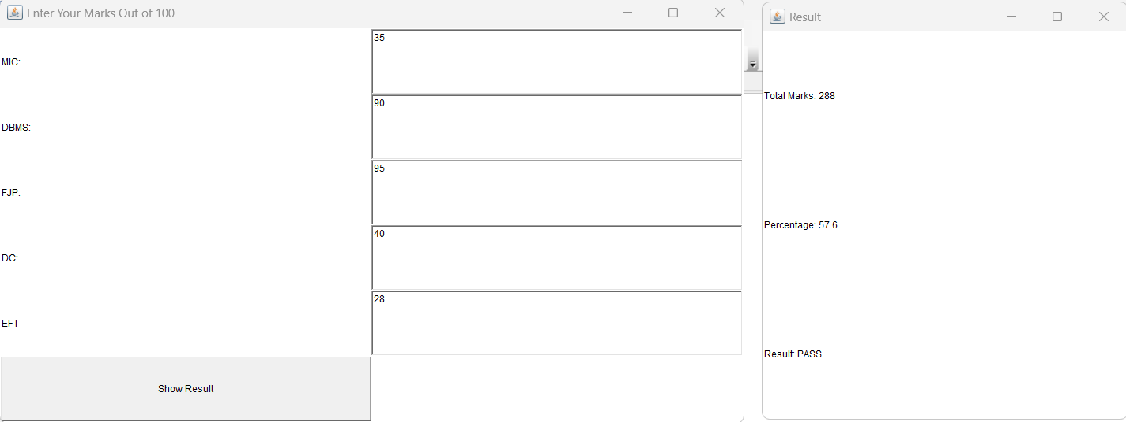

Exp 4B
import javax.swing.*;
import java.awt.event.*;

public class MenuDemo extends JFrame implements ActionListener {

JMenuBar mb;
JMenu file, edit, view;
JMenuItem newItem, openItem;

public MenuDemo() {
setTitle("Menu Bar Example");
setSize(400, 300);

// Create Menu Bar
mb = new JMenuBar();

// Create Menus
file = new JMenu("File");
edit = new JMenu("Edit");
view = new JMenu("View");

// Create Submenu Items under File
newItem = new JMenuItem("New");
openItem = new JMenuItem("Open");

// Add action listeners
newItem.addActionListener(this);
openItem.addActionListener(this);

// Add submenu items to File menu
file.add(newItem);
file.add(openItem);

// Add menus to MenuBar
mb.add(file);
mb.add(edit);
mb.add(view);

// Set MenuBar to Frame
setJMenuBar(mb);

setDefaultCloseOperation(JFrame.EXIT_ON_CLOSE);
setVisible(true);
}

// Handle Menu Clicks
public void actionPerformed(ActionEvent e) {
if (e.getSource() == newItem) {
JOptionPane.showMessageDialog(this, "New File Selected");
} else if (e.getSource() == openItem) {
JOptionPane.showMessageDialog(this, "Open File Selected");
}
}

public static void main(String[] args) {
new MenuDemo();
}
}

Output
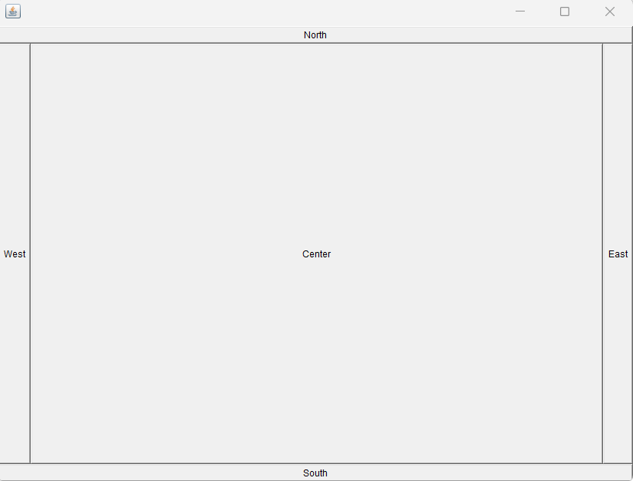

Output
